

Swinburne University of Technology
Lab03
REPORT
Applied Machine Learning - COS30082
Student Name: Truong Ngoc Gia Hieu
Student ID (VietNam): SWS01217
StudentID (Australia): 105565520
First and foremost, the third laboratory of the Applied Machine Learning (COS30082) course aims to build, train, and evaluate machine learning models using TensorFlow and Keras library. In detail, the lab guide leads students through data reprocessing and normalization, implements both single-feature and multi-feature linear regression and deep neural networks (DNNs), compares their performance using metrics such as mean absolute error (MAE), and visualizes predictions from the best-performing model to demonstrate real-world predictive capability.
Subsequently, I need to download file in the .csv format from Kaggle website, load and exploratory data before moving to next step.
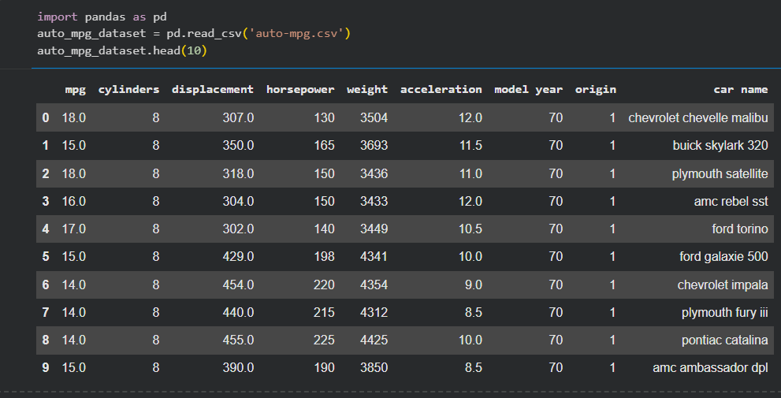
Figure 1: First ten rows of the auto-mpg dateset.
In addition, I utilized the .head(10) method to print the first 10 rows of the dateset, the .info() method to inspect the data types and non-null counts, and the .describe() method to generate a statistical summary including the mean, median, standard deviation, and other metrics.
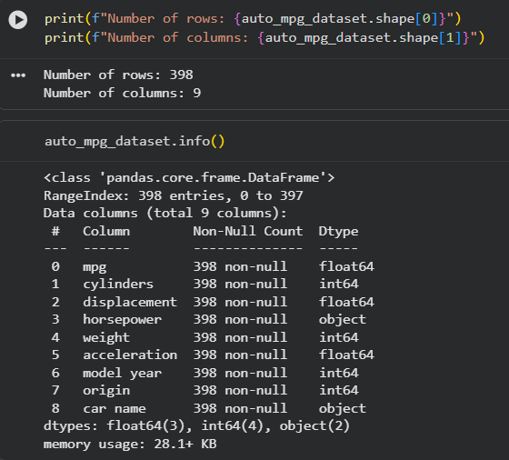
Figure 2: Dateset structure and information summary.
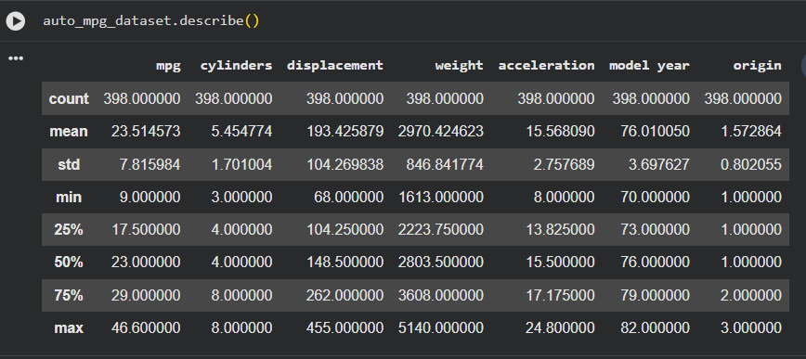
Figure 3: Statistical summary of the auto-mpg dateset
Next, I utilized the .isnull().sum() method to count the missing values in the dateset and the .shape attribute to verify its dimensions after data cleaning.
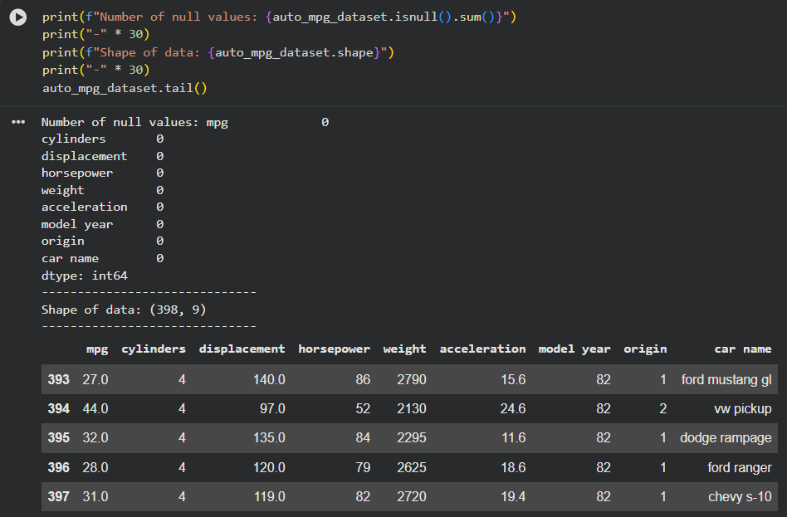
Figure 4: Checking missing values, dateset shape, and viewing the last rows of the dateset.

